Q1: Create Probability Transition matrix P for following graph, where vertex 1, 2 and 3 represent states.

The teleportation probability of 0.5. Note P[i][j] should be the transition probability from state i to state j.

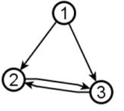

Q2: Given that at time t=0 the probability vector is [1 0 0] (for state 1, 2, 3 resp.). Find the probability vector at time t=1, using probability transition matrix (as given in Manning)

Q2: Given that at time t=0 the probability vector is [0.5 0.5 0] (for state 1, 2, 3 resp.). Find the probability vector at time t=1, using the method given in Croft. (Note that you cannot use probability transition matrix in this question)